WEDNESDAYS – Columbia City Farmers Market, CCFM
Location: S. Edmunds St between 35th Ave S and 37th Ave S at Columbia Park, 98118
Between Martin Luther King Way and Rainier Ave S

Market dates: May 8 – October 9, 2019 Market Hours: 3pm – 7pm

Market Manager Phone Number: 206-841-2374 Market Manager: Jonica Strongman

MARKET PROFILE
The Columbia City Farmers Market opened 1998, and has grown with the diverse and cohesive community around it. The market averages over 2,500 shoppers a day, with many families using the park to gather and picnic on market day. There are an average of 50 vendors occupying S. Edmunds, and Columbia Park.
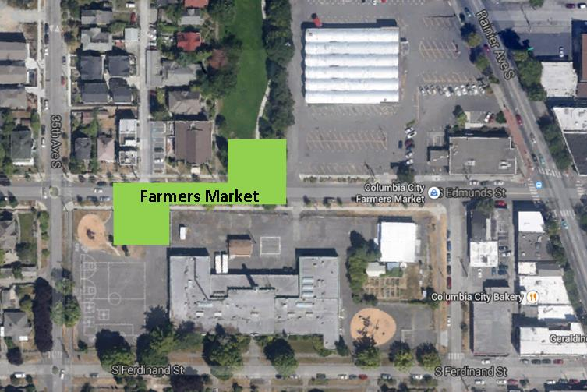

OPERATIONAL GUIDELINES

CCFM Information Booth
- Located on S. Edmunds near the alley between 35th and 36th.
- If using GPS to locate market, search PCC Columbia City.
- If you do not have a space assignment, please stop by the Information Booth or look for the manager.

Unloading and Loading
- Set up begins at noon and no earlier.
- Vehicles may not enter the park.
- All vehicles must exit the market by 2:30 and may not re-enter until 7:15.
- Breakdown is not allowed before the market closes at 7 p.m.
- The loading protocol is based on your location in the market. Please see the attached.

Columbia City Farmers Market Loading Protocol:

Vendors East of the Info Booth/Alley:
- Enter from Rainier
- Park on the North side of the street leaving room for vendors to pass to the south.
- Bring your vehicle only after you have broken down and are ready to load.
- Please be considerate of your neighbors!

Vendor West of the Info Booth/Alley:
- Enter from 35th
- Park on the South side of the street leaving room for vendors to pass to the north
- Bring your vehicle only after you have broken down and are ready to load.
- Please be considerate of your neighbors!

INFO
Alley
Park

Parking
- We will provide a map of available parking in the neighborhood.
- Vendor staff and extra vehicles must park more than 3 blocks away to allow for shopper access to the market.

Restrooms
Bathroom facilities are available in PCC.

Water
Non-potable water is available from the garden hose at the southwestern edge of the park, off the South Side Commons building, and eventually at the PCC.

ATM
The closest ATM machine is located at the Bank of America on the corner of Edmunds and Rainier.

Food Bank Collection
The Rainier Valley Food Bank collects donated food at the end of each market day.

Social Media
- Facebook: facebook.com/ColumbiaCityFarmersMarket/
- Twitter: SeattleFarmMkts
- Instagram: @seattlefarmersmkts

Weather-related cancellations
All NFMA markets are open rain or shine. However, since markets are held in open-air venues, we reserve the right to close a market if it is determined that severe weather conditions could comprise the safety of vendors and shoppers. See our vendor rules for guidelines.

Driving Directions

Nearby landmarks: Columbia Park, PCC Natural Markets Columbia City

From the South
Follow I-5 N to Martin Luther King Jr Way S in Tukwila. Take exit 157 from I-5 N
Follow Martin Luther King Jr Way S to 37th Ave S in Seattle, 4.1 mi / 9 min
Turn right onto S Alaska St
Turn right onto Rainier Ave S
Take the next right onto S Edmunds St

From the North
Take I-5 S
Take exit 163A toward Columbian Way
Merge onto S Columbian Way
Slight right onto 15th Ave S
Slight left onto S Columbian Way
Continue onto S Alaska St
Turn right onto Rainier Ave S
Take the next right onto S Edmunds St

